AIR QUALITY ANALYSIS
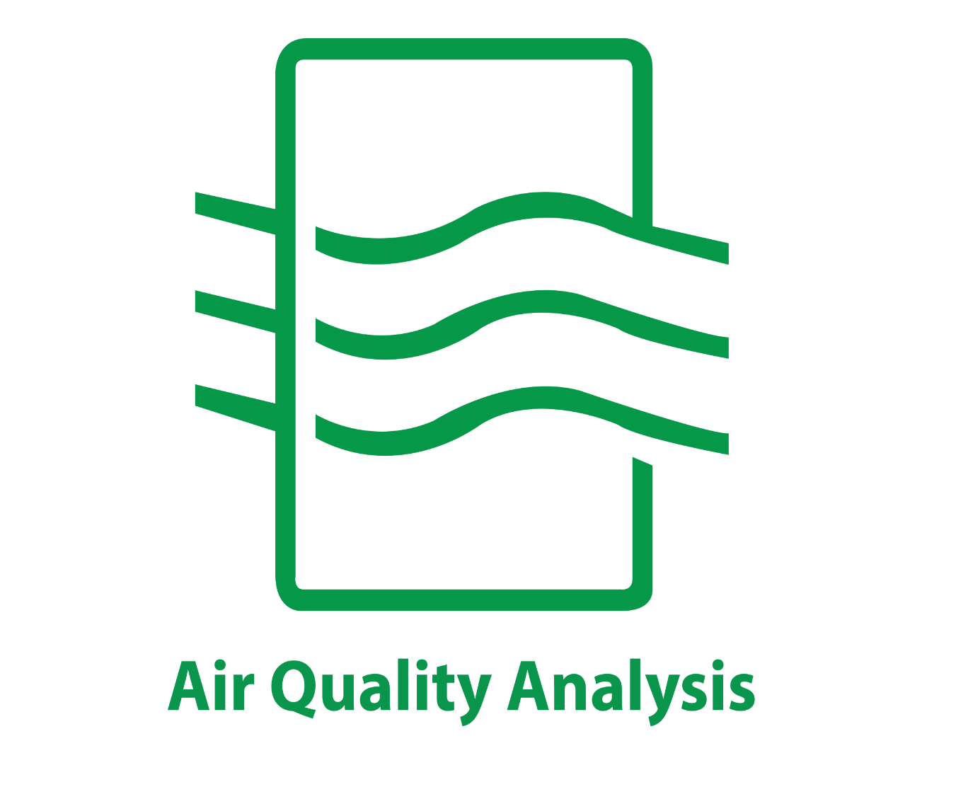PRESENTED BY,
M.ABIRAMI
M.KALAIYARASI
T.SIVARANJANI
M.YUKESHWARI

OBJECTIVES

1) DATA COLLECTION
2)DATA IMPORTING
3)DATA ANALYSING
4)DATA PREPROCESSING
5)DATA VISUALIZATION.

